Cayuga Dressage & Combined Training Presents the

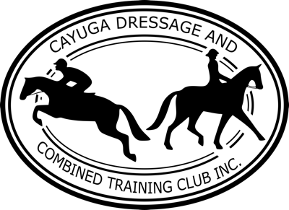
Keepin’ It Casual
Dressage Schooling Show

June 19, 2022
at Asbury Equestrian Center
543 Asbury Road, Freeville, NY 13068

USDF Regional Schooling Show Awards Program and Thoroughbred Incentive Program (TIP) award eligible. Offering USDF Intro through Third Level, Test of Choice, Dressage Seat Equitation, Western Dressage, Musical Freestyle, Prix Caprilli, and more!

Opening Date: May 20, 2022
Closing Date: June 10, 2022
Entries must be received by the closing date!

OFFICIALS
Co-Managers: Tina Matejka Norm Johnson
607-738-9007 607-280-6814
Canter2u2@gmail.com njohnson@ithaca.edu

Show Secretary: Karen Steffy
2 Hurd Road,
Freeville, NY 13068
dressageithaca@gmail.com

Judge: Celeste Brown, “L” with distinction, USDF Bronze and Silver Medalist.

Awards: Ribbons 1st – 6th ~ Jr riders (18 and under) pinned separately from adults.

Special Awards: Special awards donated by club members and sponsors. Eligible thoroughbreds can earn additional awards, please provide TIP number on entry form. Visit www.tjctip.com for list of awards.

RULES
Management reserves the right to cancel, combine, or change the order of classes as deemed necessary. We will be following current Tompkins County COVID-19 mandates.

The show will begin at 8:30 AM and will end after the last test is ridden.

All tests will be ridden in a large size (20m x 60m) indoor dressage arena. Warm-up will be in an outdoor ring, rain or shine.

The show is an informal schooling show. The dress code is neat and tidy, braids are optional. ASTM/SEI Certified helmets are required when mounted.

Class fees are listed in the table below and are dependent on CDCT membership status. Join today and save on entry fees! www.cayugadressage.org/membership

A limited number of stalls are available for $35/stall. No tack stalls are available. All stalls must be stripped at the end of the day. Shavings not provided.

There will be NO refunds for changes or cancellations after the closing date, no exceptions.

In the event of a test change after the closing date, your ride times will remain the same regardless of tests chosen. Ride times will be posted on the CDCT website at least three days prior to the show date - www.cayugadressage.org. There is a class change fee of $15 after the closing date.

All USDF dressage test scores will be reported to the USDF for inclusion into the Regional Schooling Show Awards Program. To be considered for an award, you must be an active GMO member at the time of the show. Please list your USDF member number on the entry form.

~~Current Pony Club Members can have their class fees waived by volunteering for a half day shift at our recognized shows! Please fill out the additional section on your entry form. Volunteering will only waive class fees - office fee, class change fee, and stabling fees still apply. You must provide a backup person to volunteer in case you are unable to make your shift.~~
CDCT Dressage in Wine County I & II
August 27 & 28, 2022
170 Fairview Road, Horseheads, NY 14845

Total number of tests ridden cannot exceed three. No dogs allowed.

All competitors are required to provide a Negative Coggins, proof of Rabies Vaccine, and proof of EHV/EIV Vaccination within one year of the show date with your entry form.

Payment can be in the form of checks or via PayPal. Checks payable to CDCT, Inc. PayPal: dressageithaca@gmail.com. There is a $40 charge for returned checks.

CLASS AND OFFICE FEES
Fee Type | CDCT Member | Non-Member | Jr – 18 and Under
Office Fee: | $20 | $25 | $15
Class Fee: Intro through Third Level; Western Dressage | $20 | $30 | $15
Class Fee: TOC - Fourth Level or Higher; Freestyle; Prix Caprilli | $30 | $45 | $25
Class Fee: Leadline | -- | -- | $10
Class Change Fee - After Closing Date | $15 | $15 | $15
COVID-19 CONSIDERATIONS
We will be following the current Tompkins County COVID-19 mandates in addition to the following:
- Entries must be RECEIVED by the closing date. If the show is cancelled due to COVID-related reasons, all entry fees will be refunded. “Acts of God” will not be refunded. No exceptions.
- All fees must be paid in full and all necessary paperwork must be submitted PRIOR to arriving to the show grounds. Upon arrival, please check in to receive your number and sign a facility waiver. Scoring will be tabulated as quickly as possible and ribbons and tests will be set out for pick up. Anything not picked up during the show will be mailed to the address on your entry form. Results will be posted on our Facebook and website following the end of the show.
- Hand sanitizer will be available outside the rest room and near ribbon and test pickup.
- Tests may be ridden out of sequential order. Riders will have at least two tests break between rides. There will be no more than five horses in the warm-up ring at any time.
- Please bring your own refreshments as none will be provided.

CLASSES
All tests will be ridden in a large size (20m x 60m) indoor dressage arena.
- Leadline (Jr)
- USDF Introductory Test A, 2019 (AA/Open/Jr)
- USDF Introductory Test B, 2019 (AA/Open/Jr)
- USDF Introductory Test C, 2019 (AA/Open/Jr)
- USEF Training Level Test 1, 2019 (AA/Open/Jr)
- USEF Training Level Test 2, 2019 (AA/Open/Jr)
- USEF Training Level Test 3, 2019 (AA/Open/Jr)
- USEF First Level Test 1, 2019 (AA/Open/Jr)
- USEF First Level Test 2, 2019 (AA/Open/Jr)
- USEF First Level Test 3, 2019 (AA/Open/Jr)
- USEF Second Level Test 1, 2019 (AA/Open/Jr)
- USEF Second Level Test 2, 2019 (AA/Open/Jr)
- USEF Second Level Test 3, 2019 (AA/Open/Jr)
- USEF Third Level Test 1, 2019 (AA/Open/Jr)
- USEF Third Level Test 2, 2019 (AA/Open/Jr)
- USEF Third Level Test 3, 2019 (AA/Open/Jr)
- Dressage Seat Equitation AA/Open
- Dressage Seat Equitation Jr
- Test of Choice – Fourth Level or Above
- Musical Freestyle
- Prix Caprilli Test of Choice
- Western Dressage/WDAA Test of Choice, 2022 (AA/Open/Jr) This class will be pinned as a group unless entries warrant individual tests.

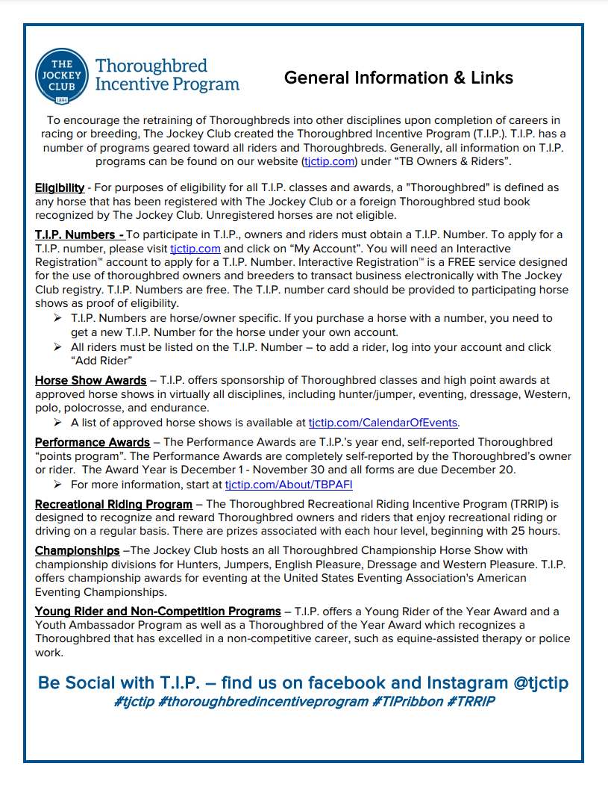
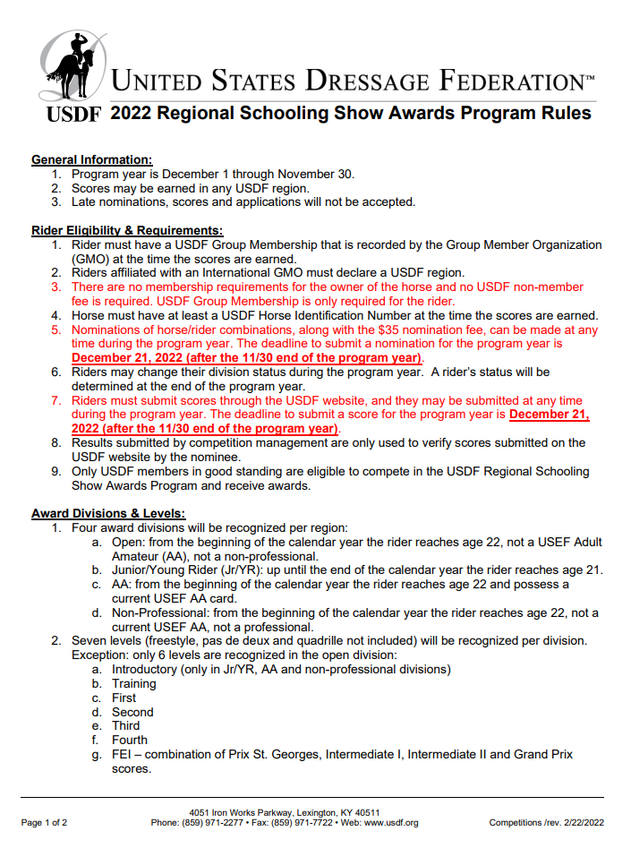
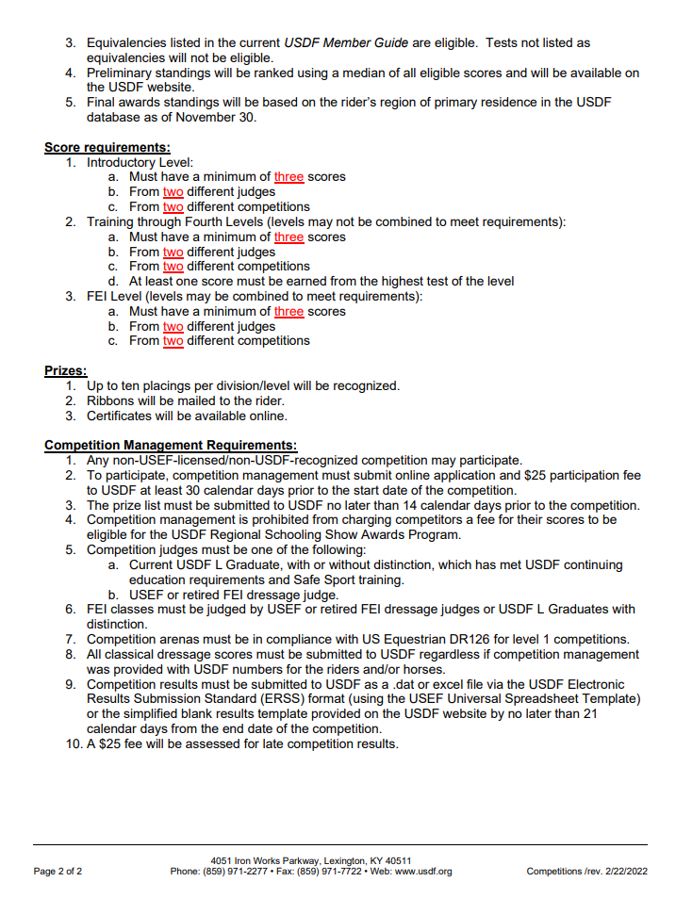
Cayuga Dressage and Combined Training Club presents the
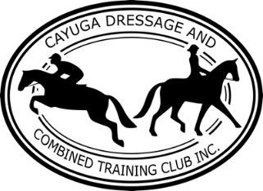
Keepin’ It Casual Show Dressage Schooling Show
June 19, 2022
at Asbury Equestrian Center
543 Asbury Road, Freeville, NY 13068

Entries must be RECEIVED by: June 10, 2022
Show Secretary: Karen Steffy, 2 Hurd Road, Freeville, NY 13068 - dressageithaca@gmail.com
Entry Form
Rider Information
Name: Email: Phone:
Member of GMO
Address:
Emergency Contact Name:
Emergency Contact Phone:
Is the rider a junior? If so, date of birth:
Signature of parent or guardian if under 18:

Horse Information
Show Name:
Gender: Breed:
Owner:
Owner GMO Membership (if different than rider):
Owner Address:
Owner Phone:
Owner Email:

Regional Schooling Show Awards & Thoroughbred Incentive Program (TIP) Awards Information
(leave blank if not applicable)
USDF Horse Identification Number:
USDF Rider Number:
USDF Horse Owner Number:
Thoroughbred Incentive Program Number:

I wish to ride in a group with the following people (if applicable):

Current Pony Club Members – Volunteer to Waive Class Fees
Name of Pony Club in which you are a member:
Please check which shift(s) you would like to volunteer for:
Saturday, August 27 – AM Sunday, August 28 – AM

Saturday, August 27 – PM Sunday, August 28 – PM
Name of replacement volunteer if unable to attend:
Phone of replacement volunteer:

Class Number Class Name Division - Circle One Fee
AA – Open – Jr AA – Open – Jr AA – Open – Jr AA – Open – Jr
Class Fee Total:
Office Fee:
Stabling Fee:
Total Fees:
My signature below indicates that I hold Cayuga Dressage and Combined Training, Inc., its Officers and Board and their heirs, Asbury Equestrian Center LLC owners and their heirs, and the USDF harmless for any harm that may occur while at this show. I also indicate that I and any members of my party agree to abide by the COVID Rules and Guidelines listed in this prize list and if asked by management or farm owners, I will mask up, socially distance, or leave the premises.

Rider Print:
Rider Signature (or parent if under 18):
Owner Print:
Owner Signature:

ENTRY FORM CHECKLIST:

Completed and Signed Entry Form.

Negative Coggins, proof of Rabies Vaccine, and proof of EHV/EIV within one year of show date.

Check or PayPal – if PayPal, provide email used:

USDF member numbers to participate in the USDF Regional Schooling Show Awards Program.

Thoroughbred Incentive Program (TIP) number if eligible for special thoroughbred awards.

